

# Report of Project Work For The Course HTML And CSS (CSE-326)

I Regds No:- 12217573 here by declare that the project work reported entitled “Travelling Website” in partial fulfilment of the requirement for the award of Degree for Bachelors of Technology in CSE at Lovely Professional University, Jalandhar, Punjab is an authentic work carried out under supervision of my supervisor Mr. Sushil Lekhi. The content of this project represents authentic and honest effort conducted, in its entirely by us. We are fully responsible for the contents of our project.

# NAME : Parth s Pandey REGISTRATION NUMBER: 12217573



**Report of Project Work For The Course HTML And CSS (CSE-326)**

# Group Members:-

**Name Registration Number Roll no.**

Parth Pandey 12217573 68

Ankit Kumar 12222386 52

Yash Pandey 12215960 70

**Submitted to-** **Mr. Sushil Lekhi**

**SCHOOL OF COMPUTER SCIENCE AND ENGNEERING LOVELY PROFESSIONAL UNIVERSITY, JALANDHAR, PUNJAB, INDIA**

# DECLERATION

We Regds No:- 12217573 , 12222386 , 12215960 here by declare that the project work reported entitled “Travelling Website” in partial fulfilment of the requirement for the award of Degree for Bachelors of Technology in CSE at Lovely Professional University, Jalandhar, Punjab is an authentic work carried out under supervision of my supervisor Mr. Sushil Lekhi. The content of this project represents authentic and honest effort conducted, in its entirely by us. We are fully responsible for the contents of our project.

Parth Pandey (Regs. No. 12217573)

Ankit Kumar(12222386)

Yash Pandey (12215960)

**INDEX**

|  |
| --- |
| **POINTERS TOPIC** |
| **1.1 INTRODUCTION** |
| **1.2 PROJECT** |
| **1.3 CODE** |
| **1.4 RESULT** |

**1.1 INTRODUCTION :-----------------------**

## HTML

HTML is an acronym which stands for Hyper Text Markup Language which is used for creating web pages and web applications. Let's see what is meant by Hypertext Markup Language, and Web page.

Hyper Text: Hyper Text simply means "Text within Text." A text has a link within it, is a hypertext. Whenever you click on a link which brings you to a new webpage, you have clicked on a hypertext. Hyper Text is a way to link two or more web pages (HTML documents) with each other.

Markup language: A markup language is a computer language that is used to apply layout and formatting conventions to a text document. Markup language makes text more interactive and dynamic. It can turn text into images, tables, links, etc.

## CSS

Cascading Style Sheets, fondly referred to as CSS, is a simply designed language intended to simplify the process of

making web pages presentable. CSS allows you to apply

styles to web pages. More importantly, CSS enables you to do this independent of the HTML that makes up each web page.

It describes how a webpage should look: it prescribes colors, fonts, spacing, and much more. In short, you can make your website look however you want. CSS lets developers and designers define how it behaves, including how elements are positioned in the browser.

While html uses tags, css uses rulesets. CSS is easy to learn and understand, but it provides powerful control over the presentation of an HTML document.

1.2 **PROJECT---------------------------**

**Hotel website**

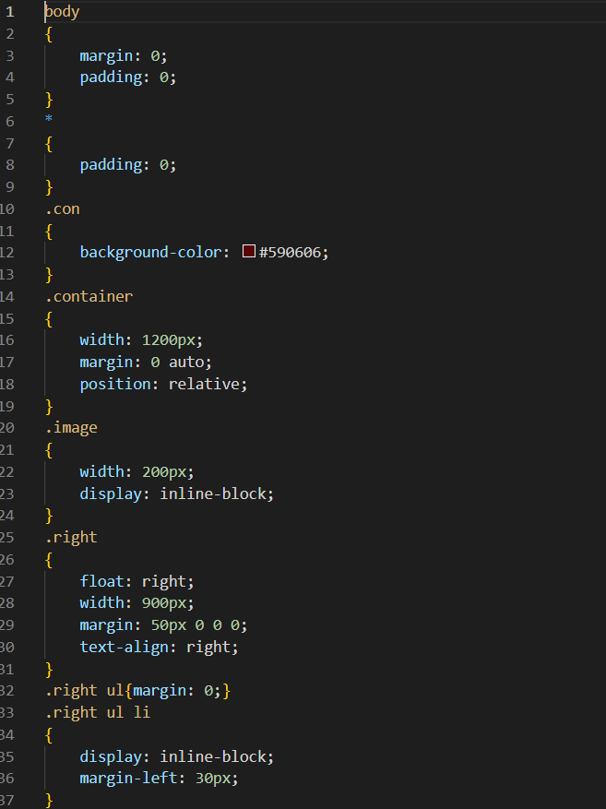

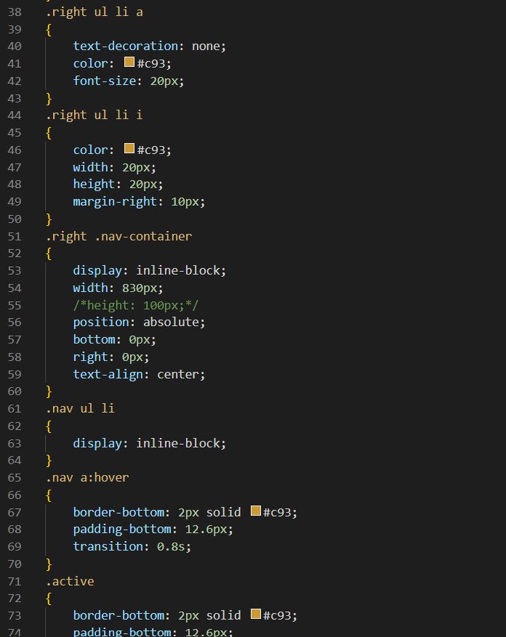

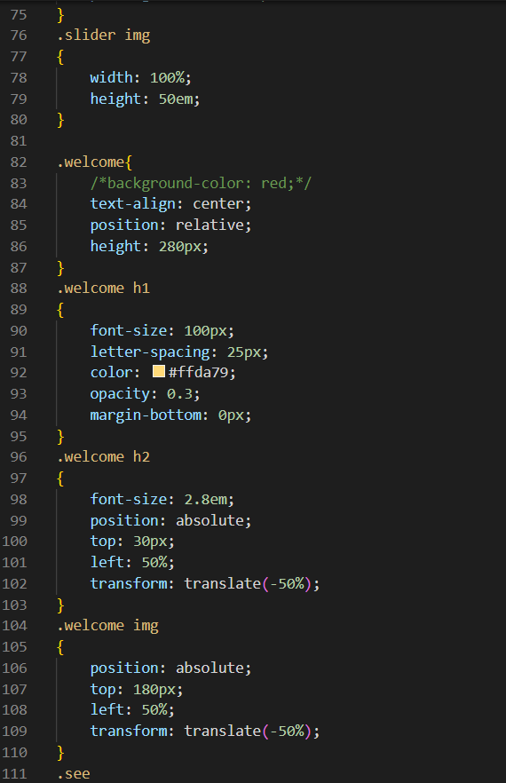

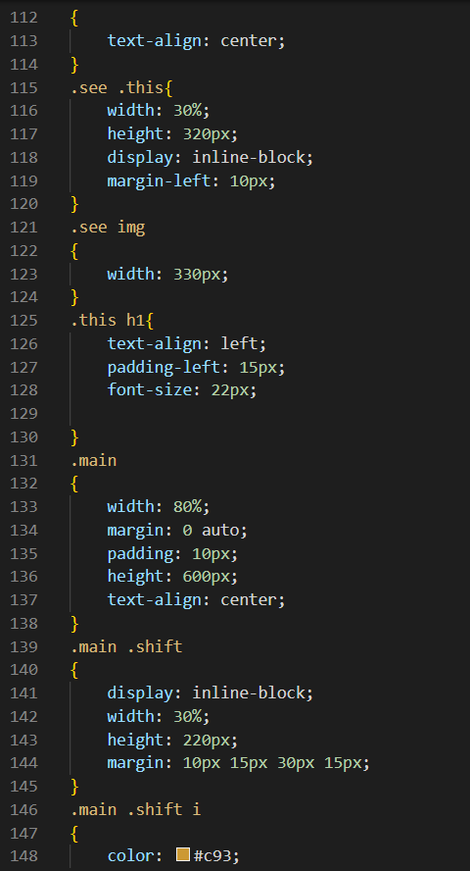

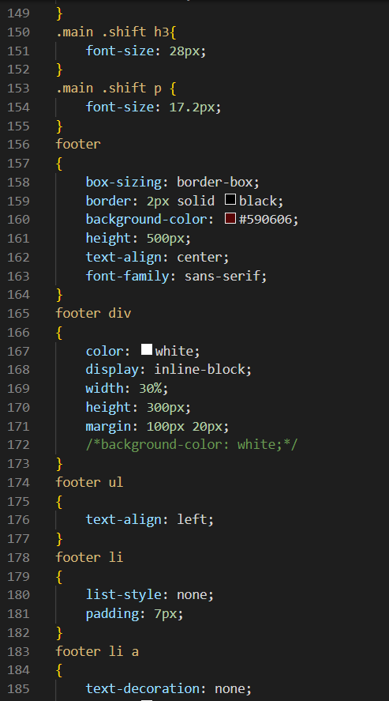

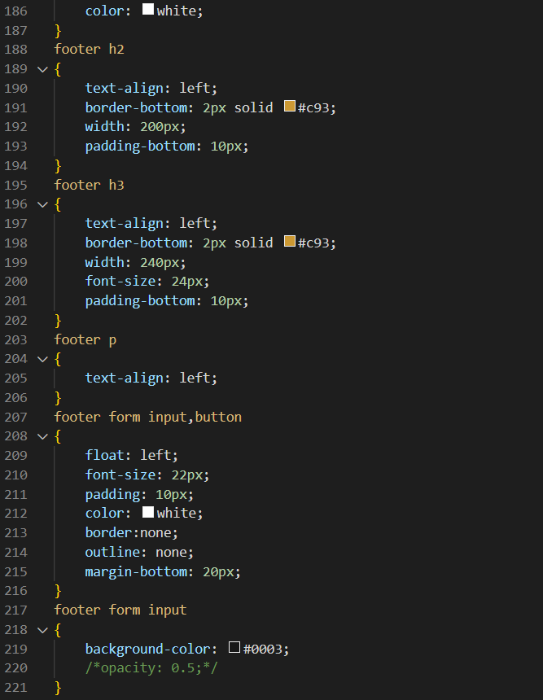

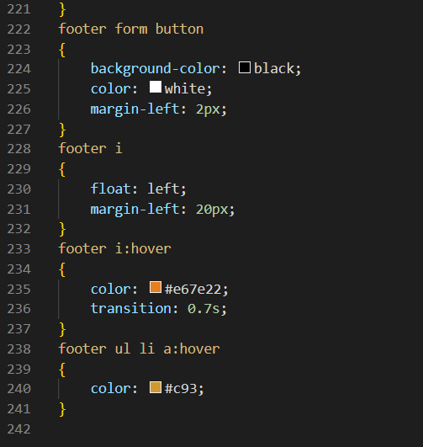

CONTACT US:-

HTML

|  |
| --- |
|  |
|  |

### 1.4 RESULT---------------------

Home page view:-

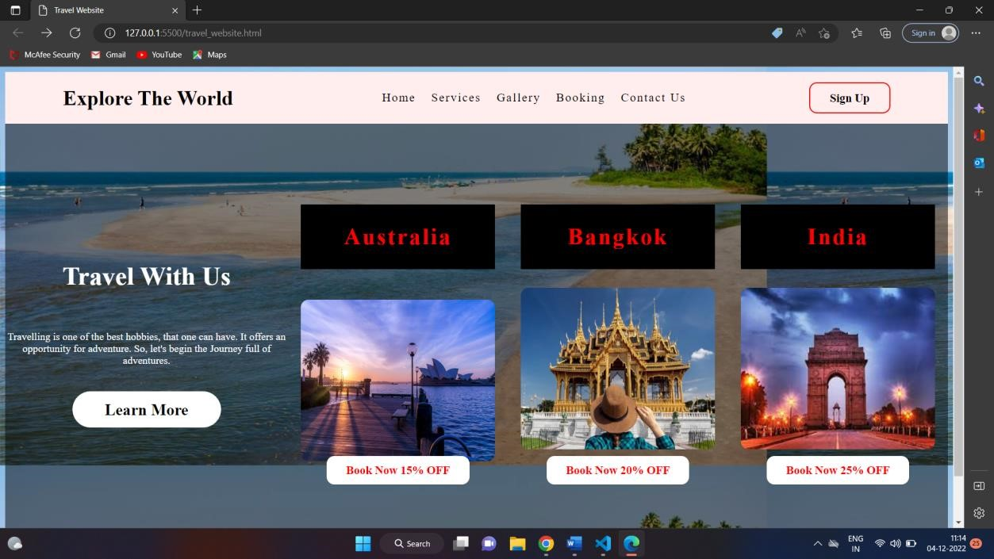

Services page view:-

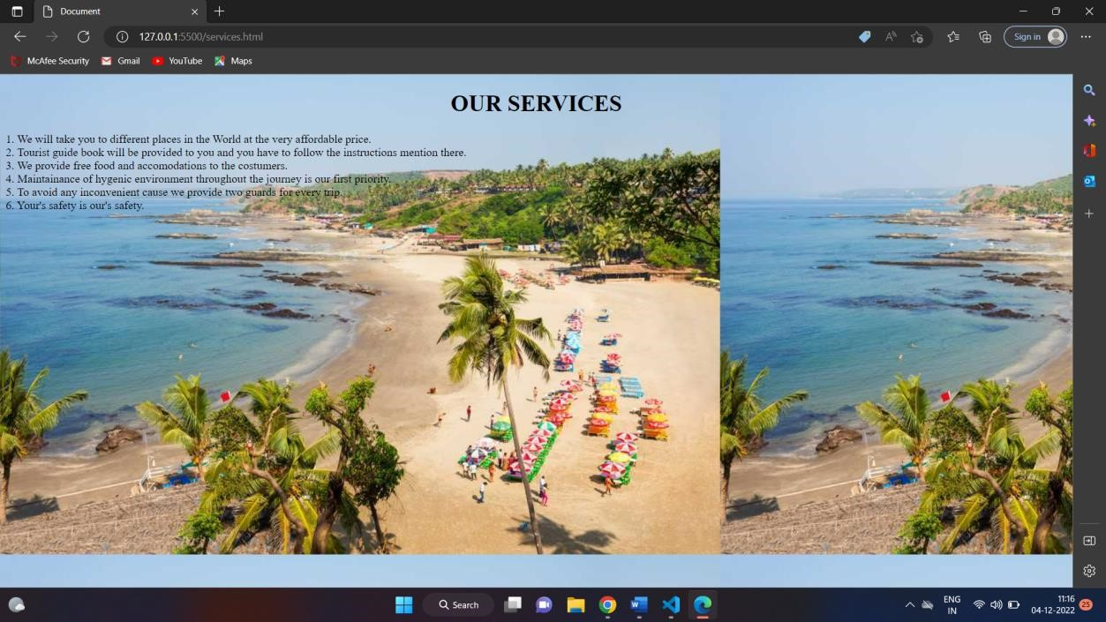

Gallery page view:-

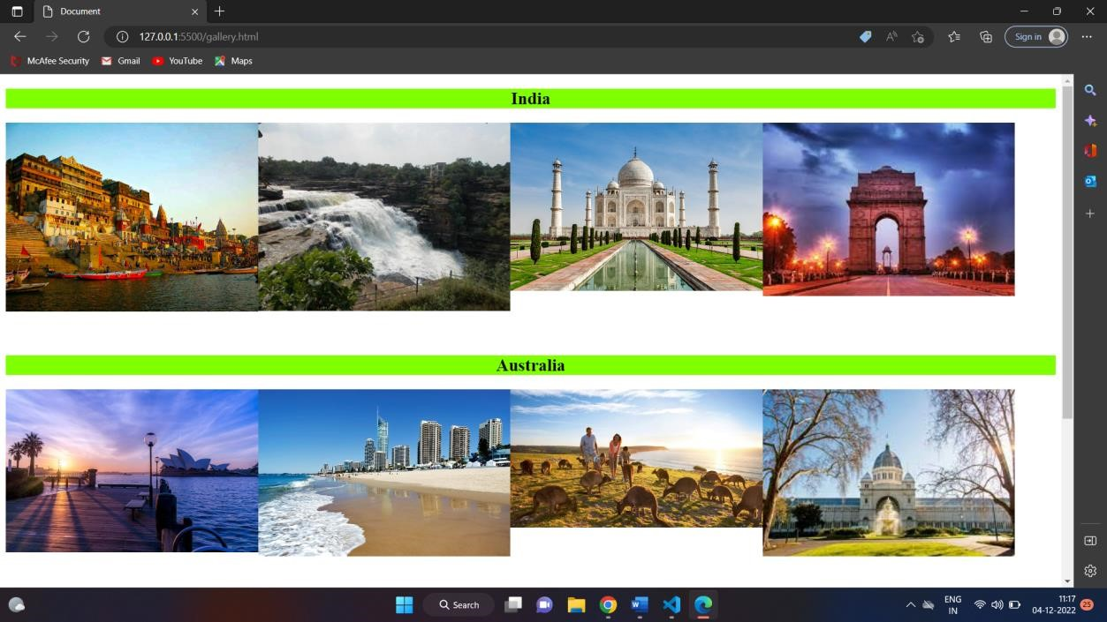

Contact us page view:-

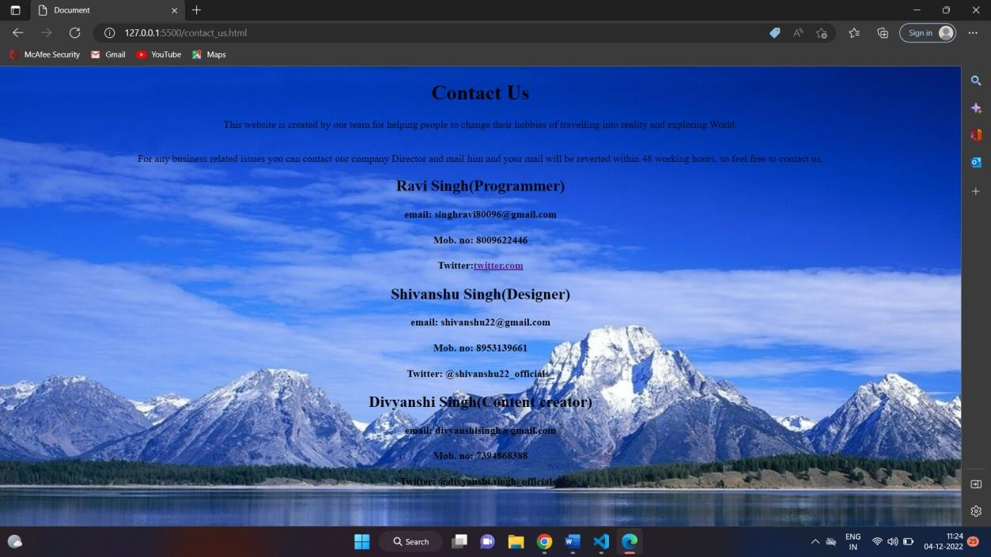

About us:

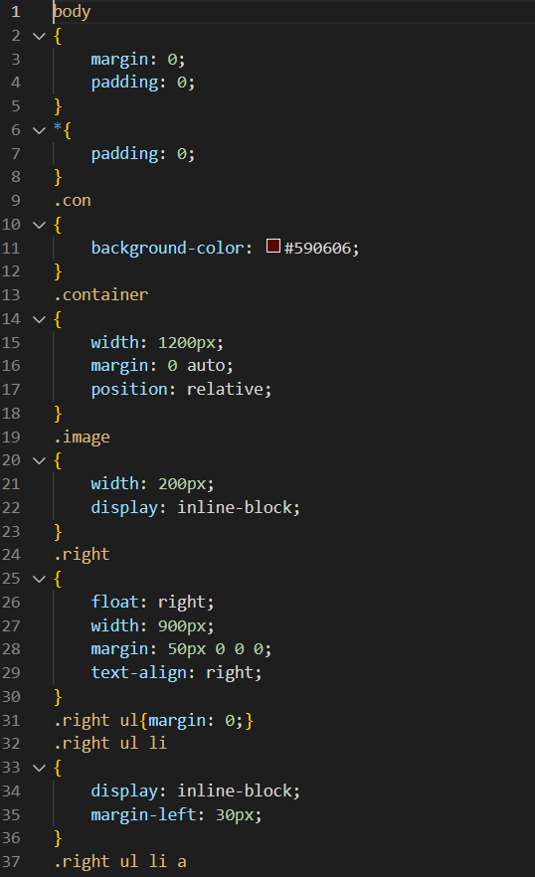

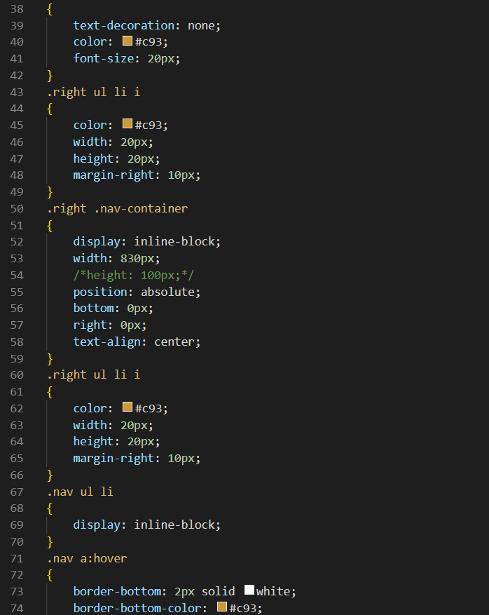

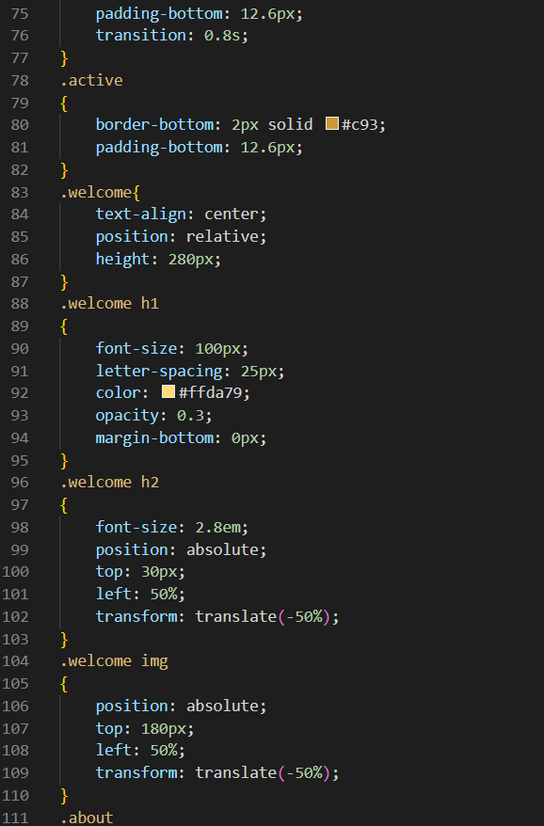

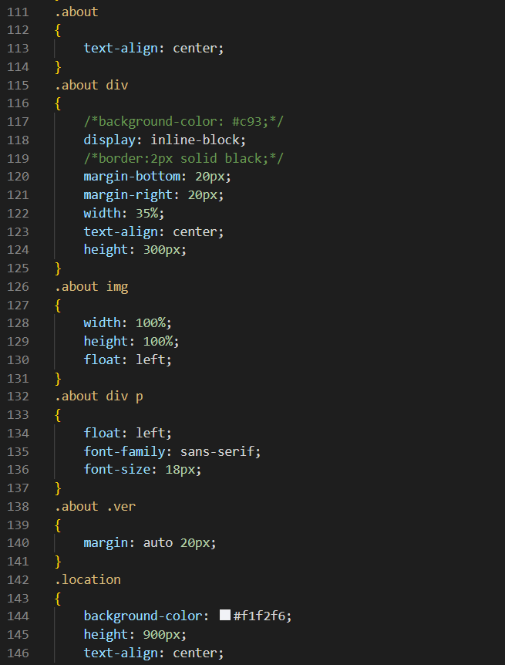

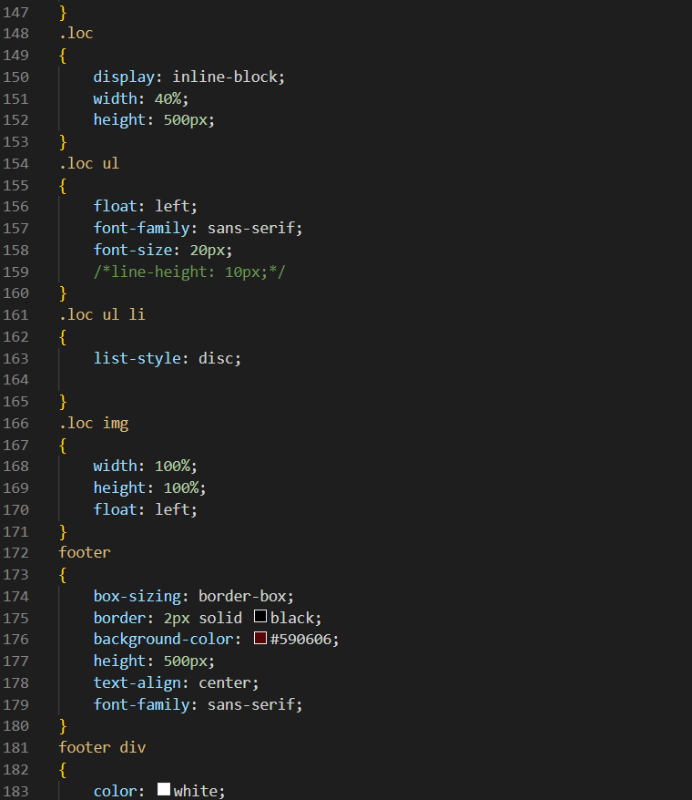

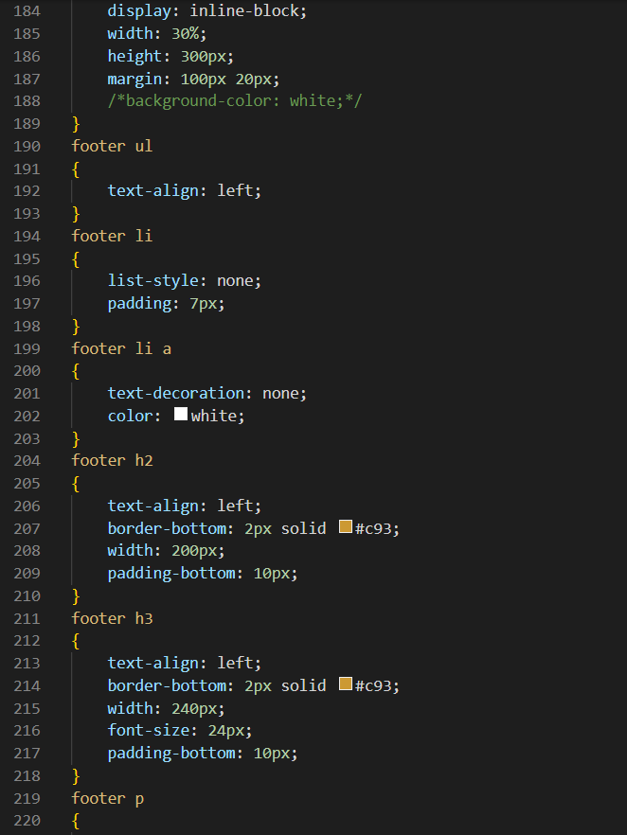

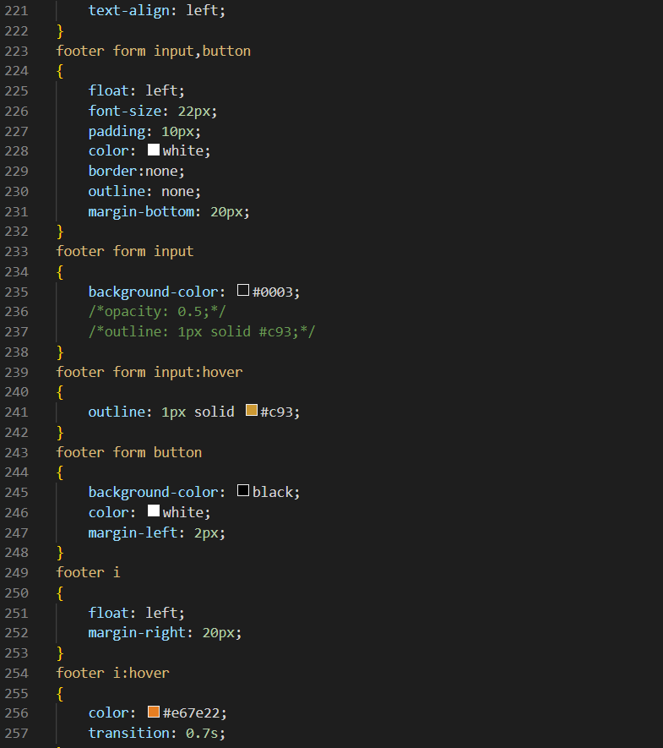

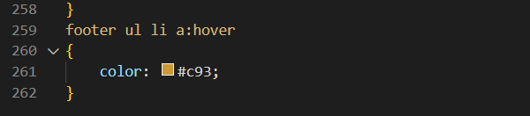

ACCOMODATION:

